Requirements specification for Marketing business process

1. General description
   1. The real estate agency gathers details about the apartment, including location, size, number of rooms, amenities, price. Take Professional photos and videos are taken, and a detailed property description is written. Then prepare the listing on our website and starts promoting apartment. It can be done by using various method, listing it on other websites, using paid promotions and publish short/ long format videos. After the campaign we collect data about campaign and put it into excel.

The increase in **the monthly profit** will increase at the level not less than 1% per month compared to the previous month.

The increase in the **ratio of views we generate for each dollar spend** will increase at the level not less than 1% per month compared to the previous month.

* 1. Question

Compare the reach of different marketing channels?

What marketing channel is has the best ratio of cost to reach?

What locations are the most desirable?

Give the channel that generate the most reach

Specify how many channels we are currently using

What external site is most effective

What marketing channel give us the most clients?

* 1. Data

All marketing data are extracted form Excel spreadsheet and properties database, or specified folder when we talk about photos or videos. Marketing information about each channels are stored, like the budget, time needed to conduct campaign, views generated (reach)

1. Data sources structures
   1. Database

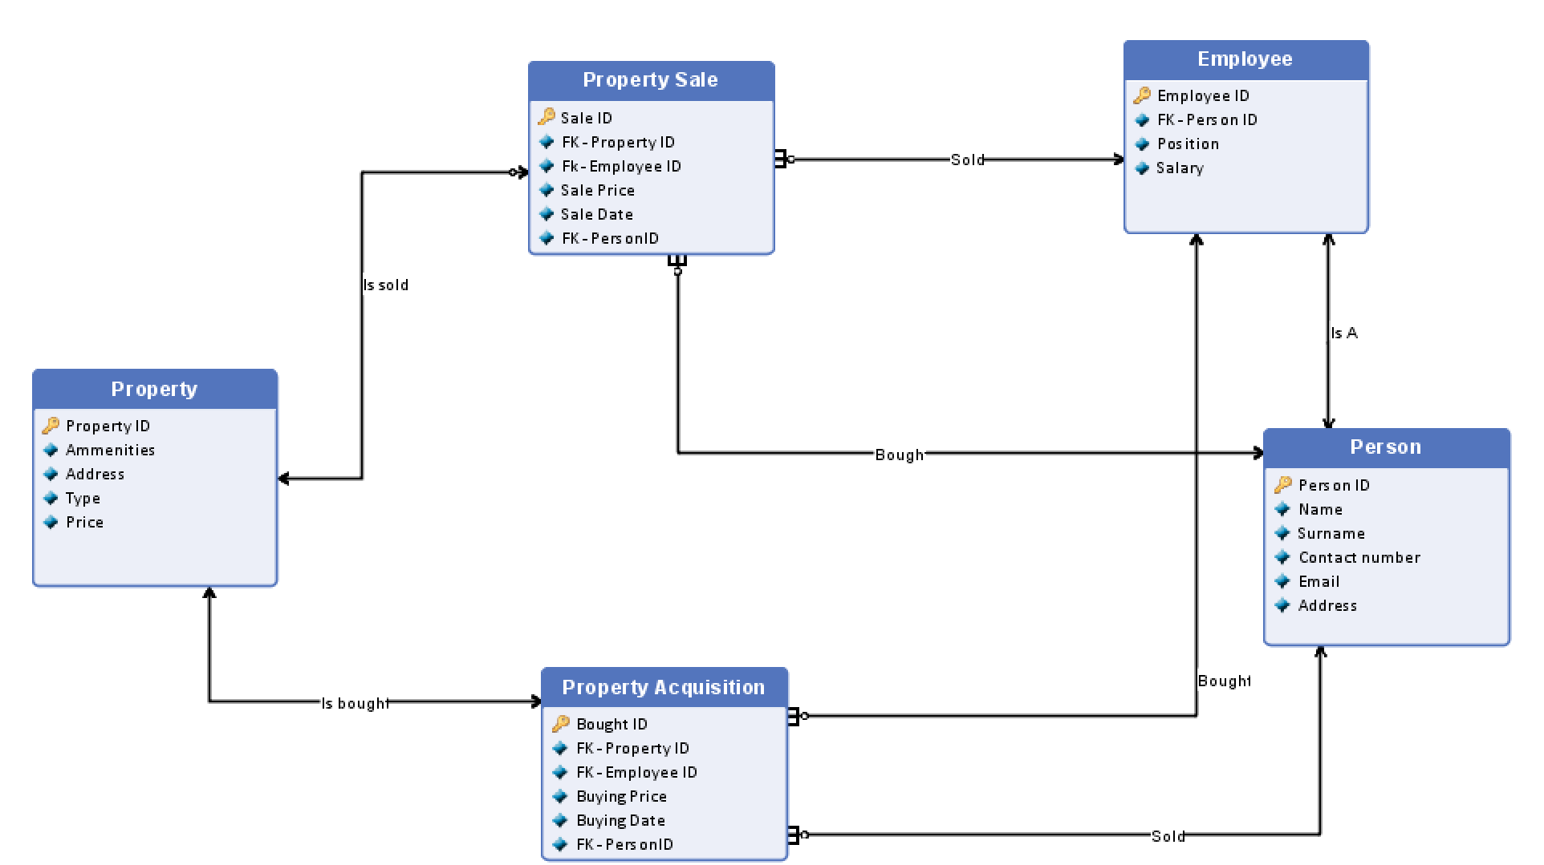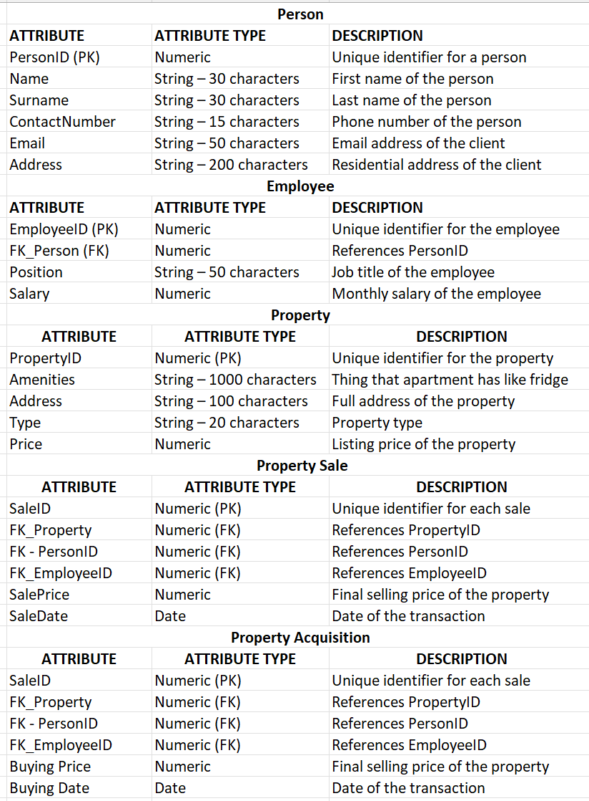

* 1. Marketing excel

Sheet 1 (Information about marketing in the real estate agency, each line describes one apartment, line 1 is a header row):

**Column A:** Property ID (Unique identifier for each property)

Column B: Money Spent on Marketing (Amount spent on marketing efforts)

Column C: Number of Views (Nv) on Our Website

Column D: Number of Views (Nv) on Competition Website

Column E: Money Spent (Ms) on Competition Website

Column F: Number of Views (Nv) on Social Media

Column G: Money Spent (Ms) on Social Media

Column H: Starting date of the campaign

Column I: Ending date of the campaign

Column J:Methods used to market( types are divided with “,”)

1. Scenarios of analytical problems Which marketing campaigns lead to the highest sales?
   1. What are the top-performing add campaigns in terms of dollar spend to views generated in the last 12 months?
   2. Did any apartment remain unsold for more than 6 months?
   3. Compare the average number of views on our website to the competition website all time?
   4. Give 3 types of best-selling apartments all time in the last year?
   5. What is average marketing cost per successful sale in the last year?
   6. Which third-party listing platforms drive the most traffic and sales in the last year? – external because we will have to use our account on different platform to get statistics

How do seasonal trends affect marketing performance?

1. Do property sales changes before and after major holidays in the last year?
2. Compare the difference in views for properties marketed with videos compared those with only images in the last year.
3. During which months do we get the highest/lowest views from marketing campaigns in the last year?
4. What are the top 5 months with the highest number of property sales all time?
5. What is the percentage increase in number of sales during each summer season compared to other seasons all time?
6. How do local events affect property demand and marketing effectiveness in the last year? – external
7. What marketing channel give us the most clients in the last year? – change process
8. Data needed for analytical problem

Analytical problem: “ Which marketing campaigns lead to the highest sales?”

1. What are the top-performing add campaigns in terms of dollar spend to views generated in the last 12 months?
   1. Starting date of the campaign – Marketing excel -Column H – to calculate period
   2. Ending date of the campaign – Marketing excel – Column I– to calculate period
   3. Money Spent (Ms) on Competition Website - Marketing excel - Column E – to calculate ratio
   4. Money Spent (Ms) on Social Media - Marketing excel - Column G – to calculate ratio
   5. Number of Views (Nv) on Our Website - Marketing excel - Column C – to calculate ratio
   6. Number of Views (Nv) on Social Media- Marketing excel - Column F – to calculate ratio
   7. Number of Views (Nv) on Competition Website - Marketing excel - Column D – to calculate ratio
2. Did any apartment remain unsold for more than 6 months?
   1. Date of sale – database – Property Sale – sale date
   2. Date of bought – database – Property Acquisition – Buyingdate – if the property has two assigned sales it was sold and the first one indicate buying date and the second selling date
3. Compare the average number of views on our website to the competition website all time?
   1. Starting date of the campaign – Marketing excel -Column H – to calculate period
   2. Ending date of the campaign – Marketing excel – Column I– to calculate period
   3. Number of Views (Nv) on Our Website - Marketing excel - Column C – to calculate ratio
   4. Number of Views (Nv) on Competition Website - Marketing excel - Column D – to calculate ratio
4. Give 3 types of best-selling apartments all time in the last year?
   1. Sale of date – Database – Property sale – date sale
   2. Property type – Database – Property – type
5. What is average marketing cost per successful sale in the last year?
   1. Date of sale – database – Property Sale – sale date
   2. Starting date of the campaign – Marketing excel -Column H – to calculate period
   3. Ending date of the campaign – Marketing excel – Column I– to calculate period
   4. Number of sales – Database – Property sale -sale ID
   5. Money sped on marketing – Marketing excel - Column B

Analytical problem: “How do seasonal trends affect marketing performance?”

1. Do property sales changes before and after major holidays in the last year?
   1. Starting date of the campaign – Marketing excel -Column H – to calculate period
   2. Ending date of the campaign – Marketing excel – Column I– to calculate period
   3. Date of sale – Database – entity sale- column Sale date– to known when it was soled
   4. Status of property to known if it was soled
   5. Number of Views (Nv) on Our Website - Marketing excel- Column C – to sum up the views
   6. Number of Views (Nv) on Competition Website- Marketing excel- Column D – to sum up the views
   7. Number of Views (Nv) on Social Media- Marketing excel - Column F – to sum up the views
2. Compare the difference in views for properties marketed with videos compared those with only images in the last year.
   1. Methods used to market - Marketing– Column J - we need it to separate the ones where videos where used from the one where only photos where used
   2. Number of Views (Nv) on Our Website - Marketing excel- Column C – to sum up the views
   3. Number of Views (Nv) on Competition Website- Marketing excel- Column D – to sum up the views
   4. Number of Views (Nv) on Social Media- Marketing excel - Column F – to sum up the views
3. During which months do we get the highest/lowest views from marketing campaigns in the last year?
   1. Starting date of the campaign – Marketing excel -Column H – to calculate period
   2. Ending date of the campaign – Marketing excel – Column I– to calculate period
   3. Number of Views (Nv) on Our Website - Marketing excel- Column C – to sum up the views
   4. Number of Views (Nv) on Competition Website- Marketing excel- Column D – to sum up the views
   5. Number of Views (Nv) on Social Media- Marketing excel - Column F – to sum up the views
4. What are the top 5 months with the highest number of property sales all time?
   1. Date of sale – database - entity Property sale – column sale date
   2. Unique sales – database – entity: Property sale – column sale ID
5. What is the percentage increase in number of sales during each summer season compared to other seasons all time?
   1. Date of sale – database - entity Property sale – column sale date
   2. Unique sales – database – entity: Property sale – column sale ID
6. How do local events affect property demand and marketing effectiveness in the last year? – external
   1. Lising of holidays – We do not have such information in our database but we can find It in the government list of holidays -external
   2. Number of Views (Nv) on Our Website - Marketing excel- Column C – to sum up the views
   3. Number of Views (Nv) on Competition Website- Marketing excel- Column D – to sum up the views
   4. Number of Views (Nv) on Social Media- Marketing excel - Column F – to sum up the views
   5. Starting date of the campaign – Marketing excel -Column H – to calculate period
   6. Ending date of the campaign – Marketing excel – Column I– to calculate period
7. What marketing channel give us the most clients in the last year? – change process
   1. How they found us - Information how they had found us after sale – we do not have such information but we can get that information by asking the customer after sales through which channel they have found us.

It is not possible to build a BI system to support Mr. Cook in solving these analytical problems without introducing additional activities in Real estate agency. We suggest to introduce a survey system every buyer. Such questionnaire should contain as minimum the following question and should be held after the sale:

* Where did you found our listing (multiple choice answers like: our site, Zillow Instagram etc.)?

This answer is automatically added to database (after giving consent of the buyer) in the sale entity in the given sale. Sample structure of the survey sheet (each row reflects a single item at the bill):

Column A – Property ID – filled by the salesman

Column B – How had you found us? – Multiple choice question